# CREATE IBM WATSON IOT PLATFORM AND DEVICE

|  |  |
| --- | --- |
| Date | 22-10-2022 |
| Team ID | PNT2022TMID17666 |
| Project Name | IOT based safety gadgetfor child safety monitoring and  notification |
| Maximum Marks | 4 Marks |
| Submitted By | Priya.v  Vasunthara.D  Janani Ishwarya.S  Janani.R |

**STEPS:**

1. Firstly create an IBM cloud account with IBMid and password

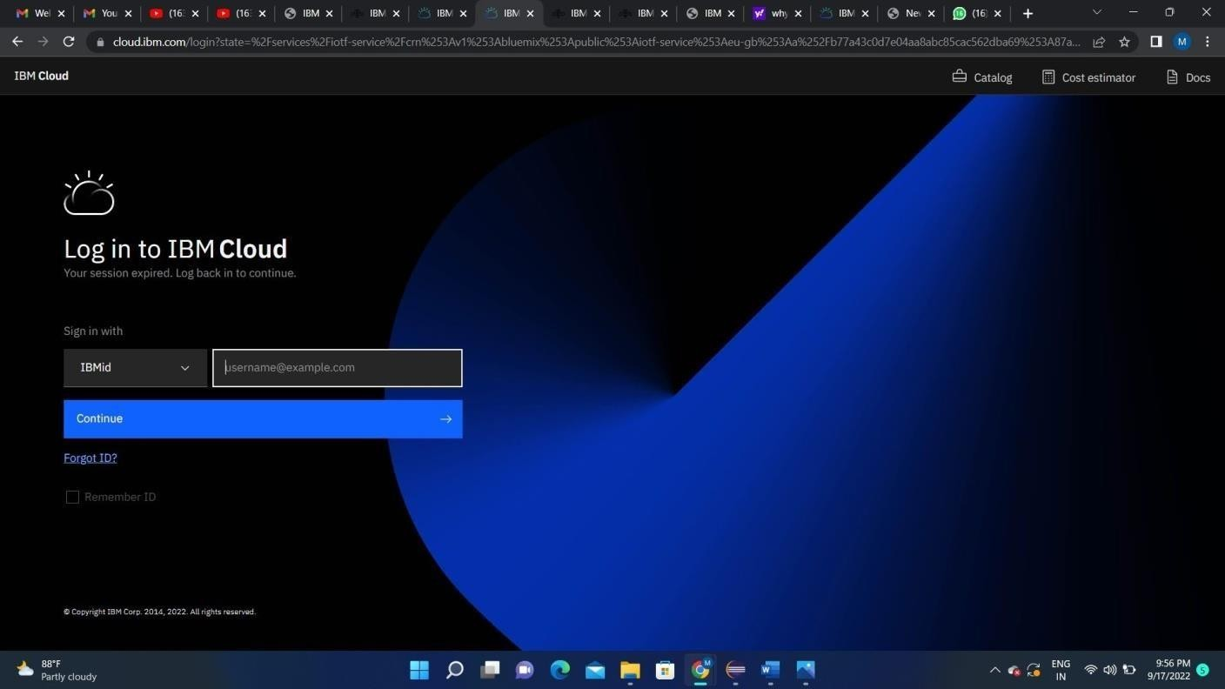

1. Home page of IBM cloud

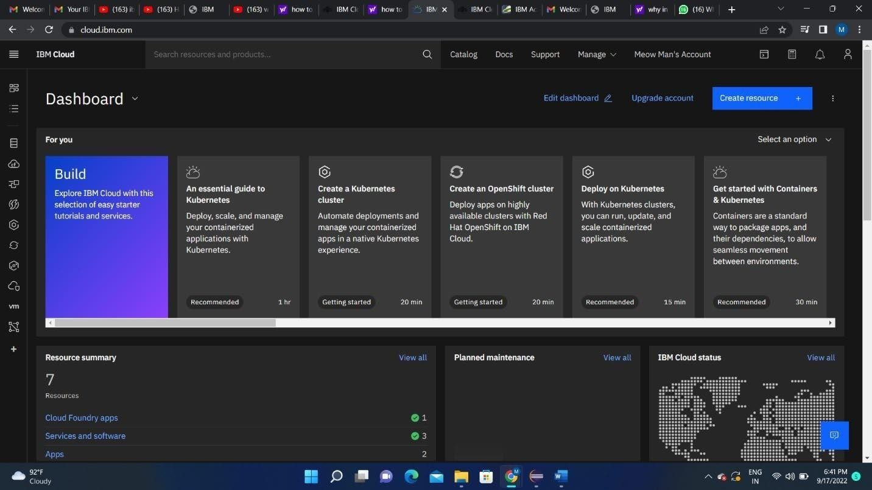

1. Click on the catalog on the top

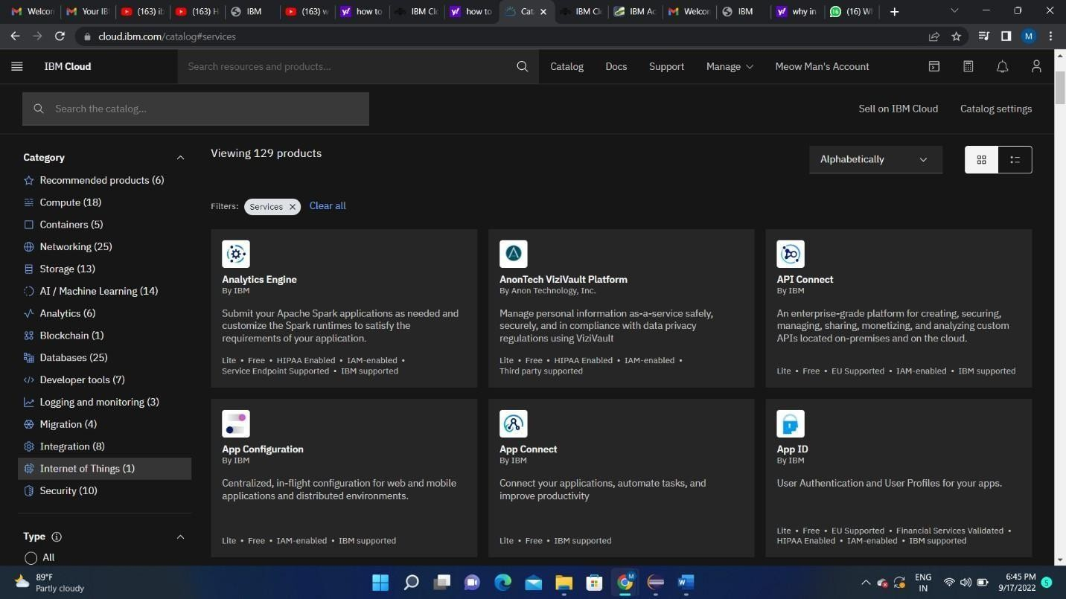

Click on IoT in the category mentioned

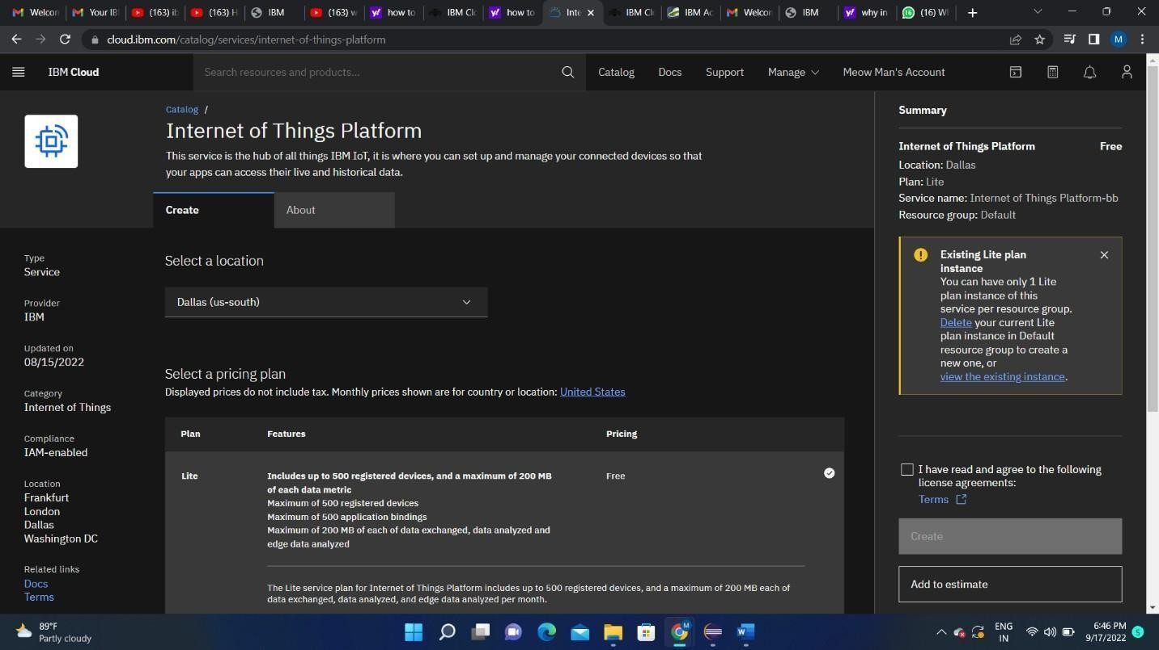

1. If already a lite is present delete it else u can’t create another

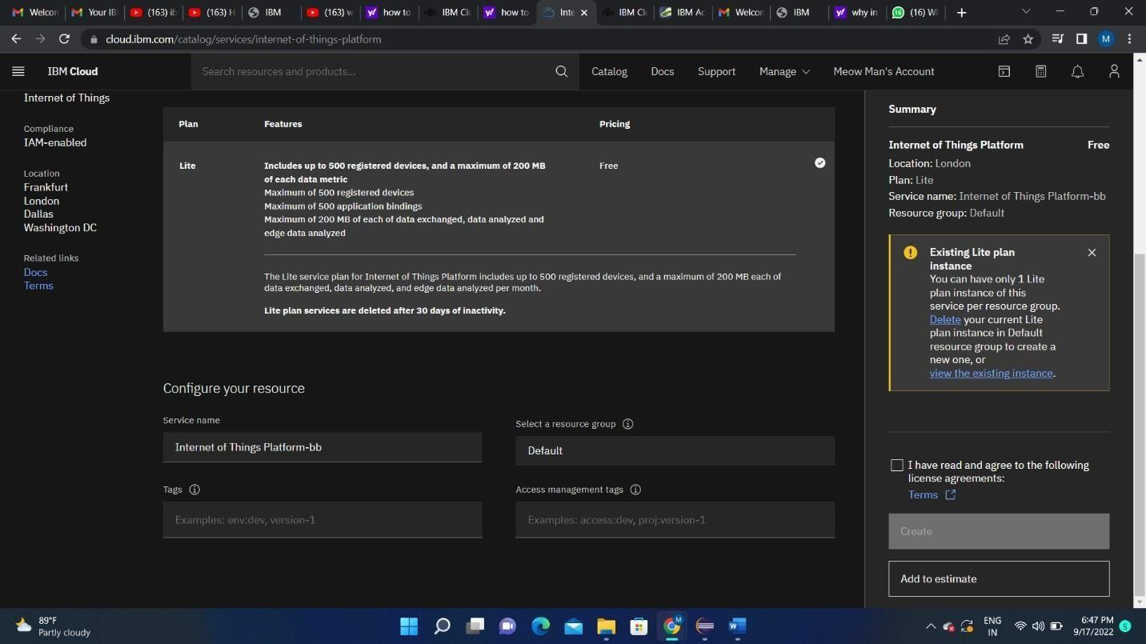

1. Enter the location and in the configure your resource type the service name and choose the plan, tick the agree with agreements and then click on create

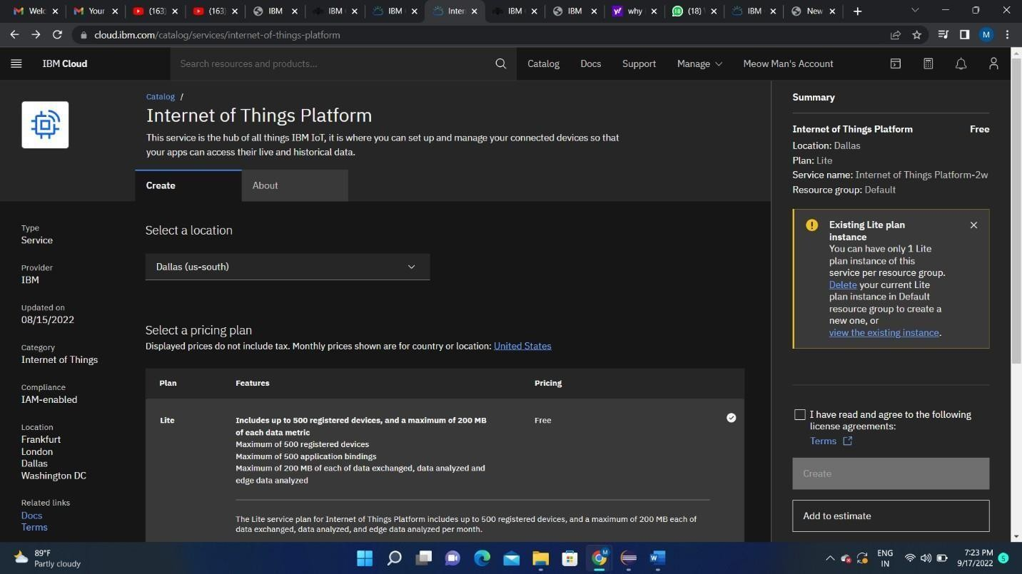

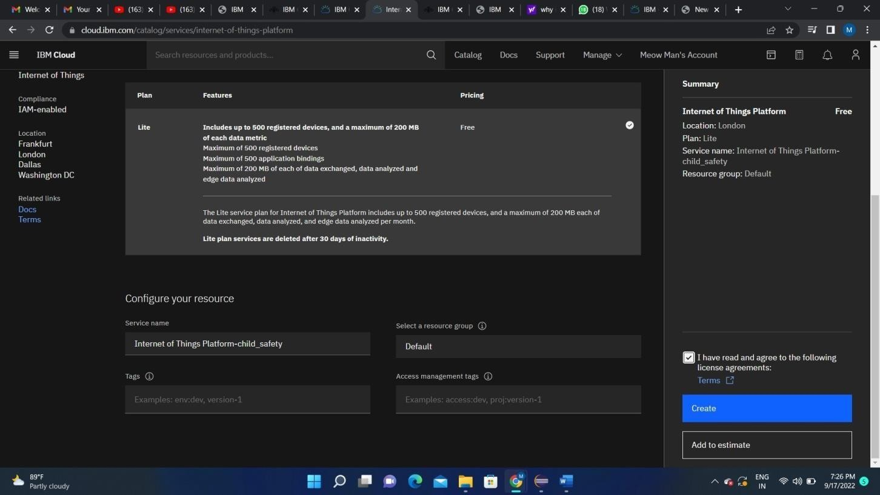

1. Internet of Things Platform Child_safety will be created, where there are different options like manage, plan, and connection ( manage is for launch, Plan gives us the idea about the payment package and its upgrades, and lastly the connection is for to connect IoT with other servies)

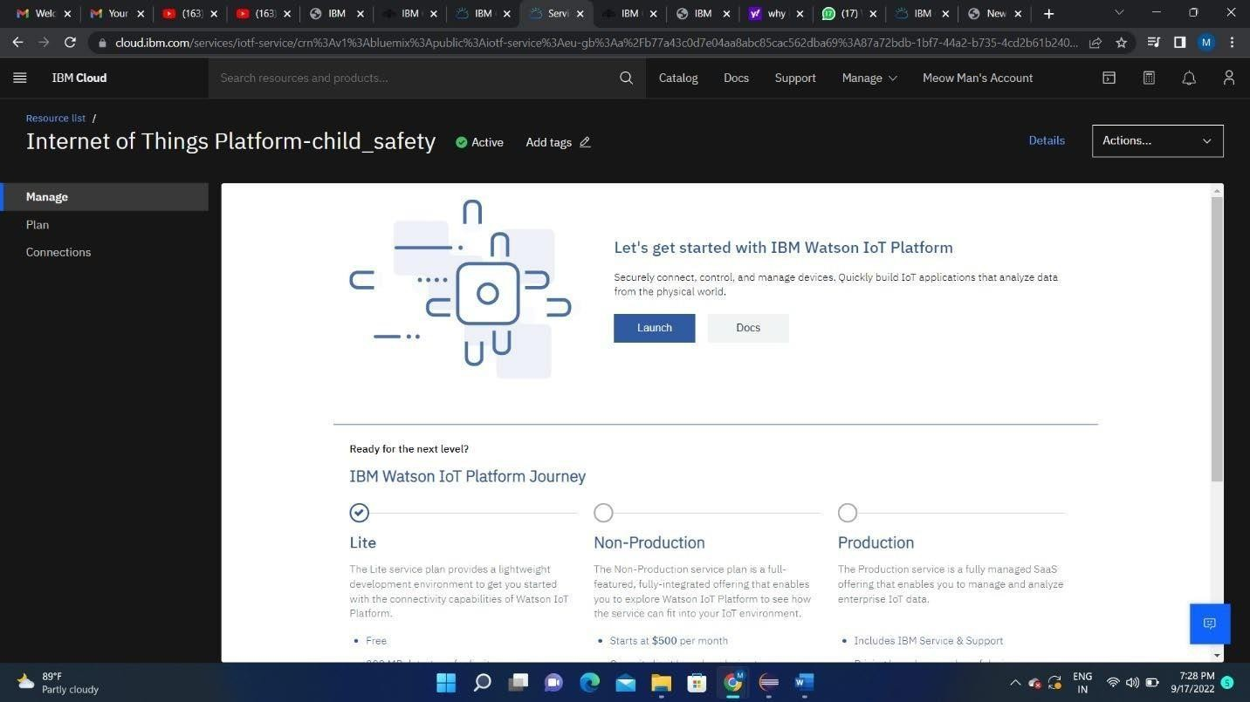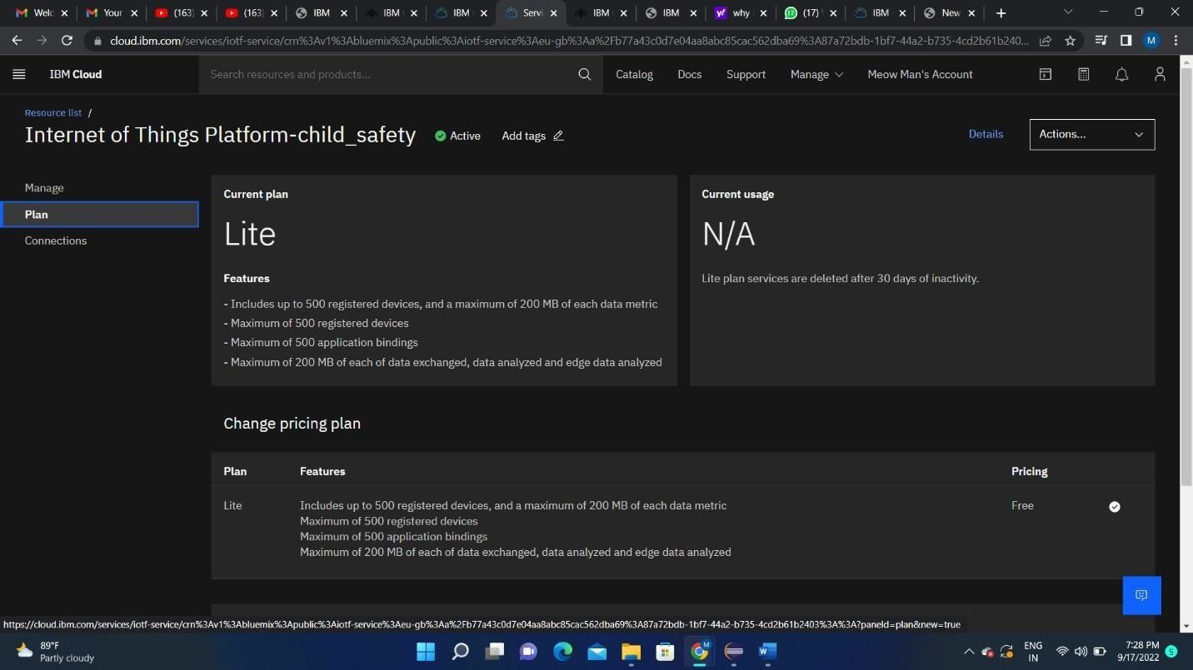

1. Clicking on the launch button in the manage tab, it will open to this

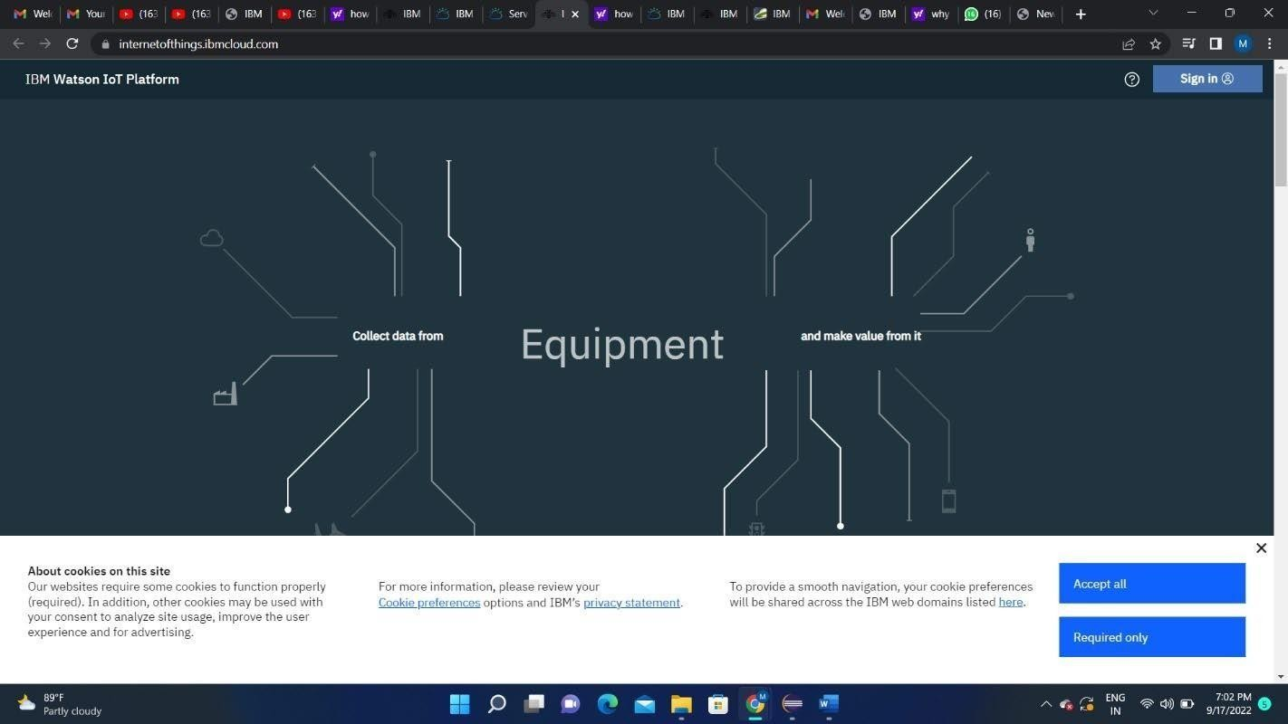

1. Enter the details to sign in to the Watson Cloud to create a device

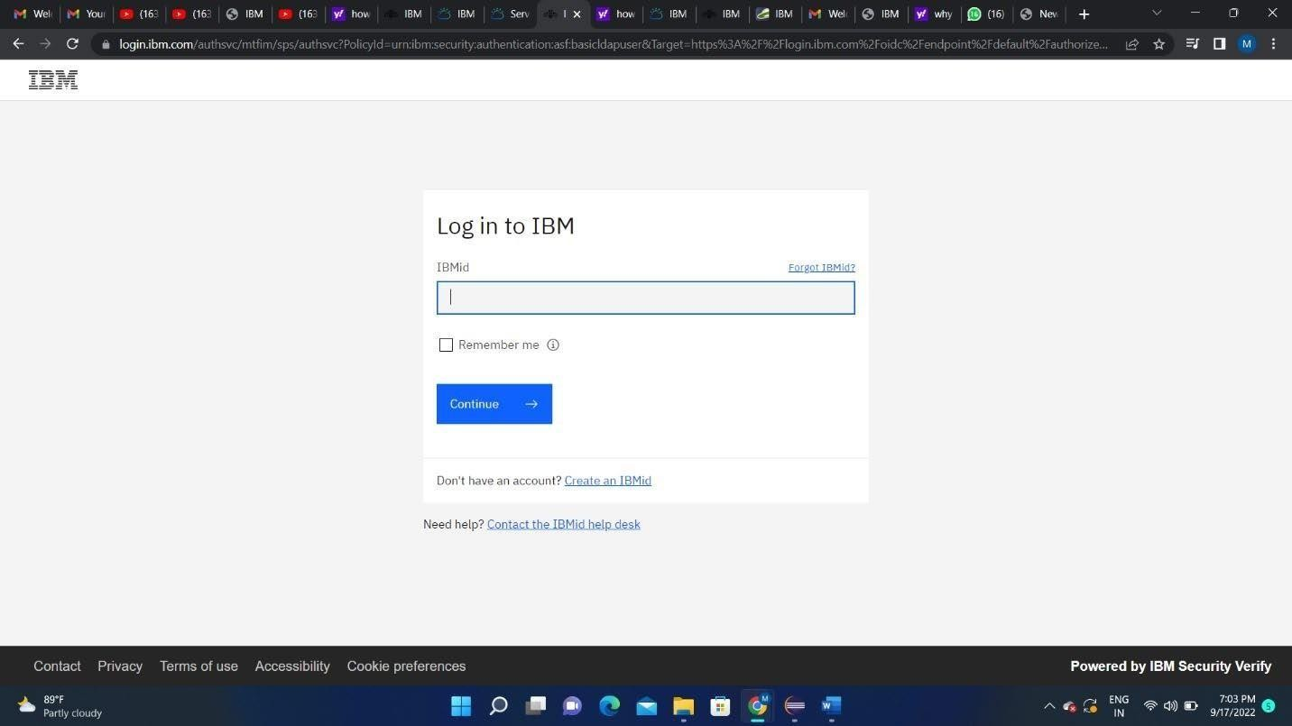

1. Once logged in the name will be displayed and it goes back to the first page

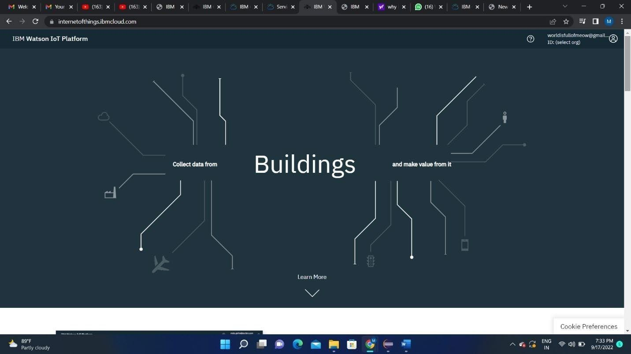

1. And again clicking on the launch button will open this tab, the device will help in the creation of the devices, the addition of devices, and the display ofdetails of the devices

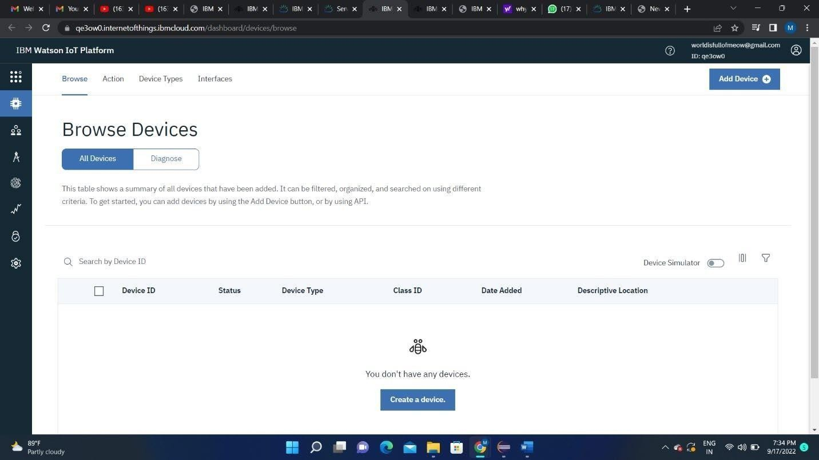

1. Usage gives the summary of how many bytes are used between the devices and the IBM cloud.

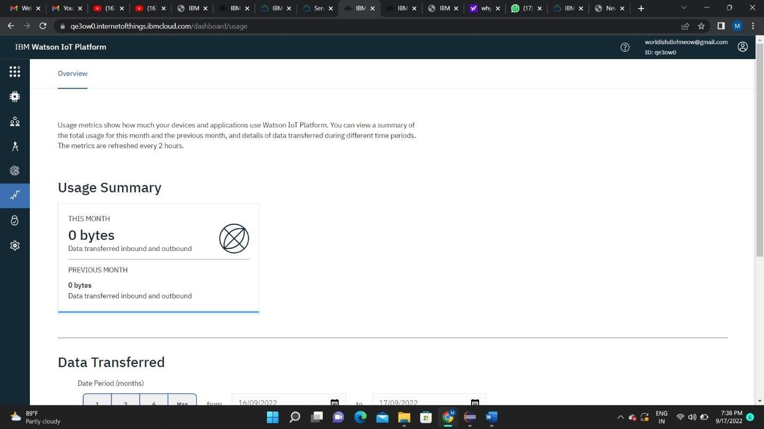

1. The member tab is add the teams members to work in the platform

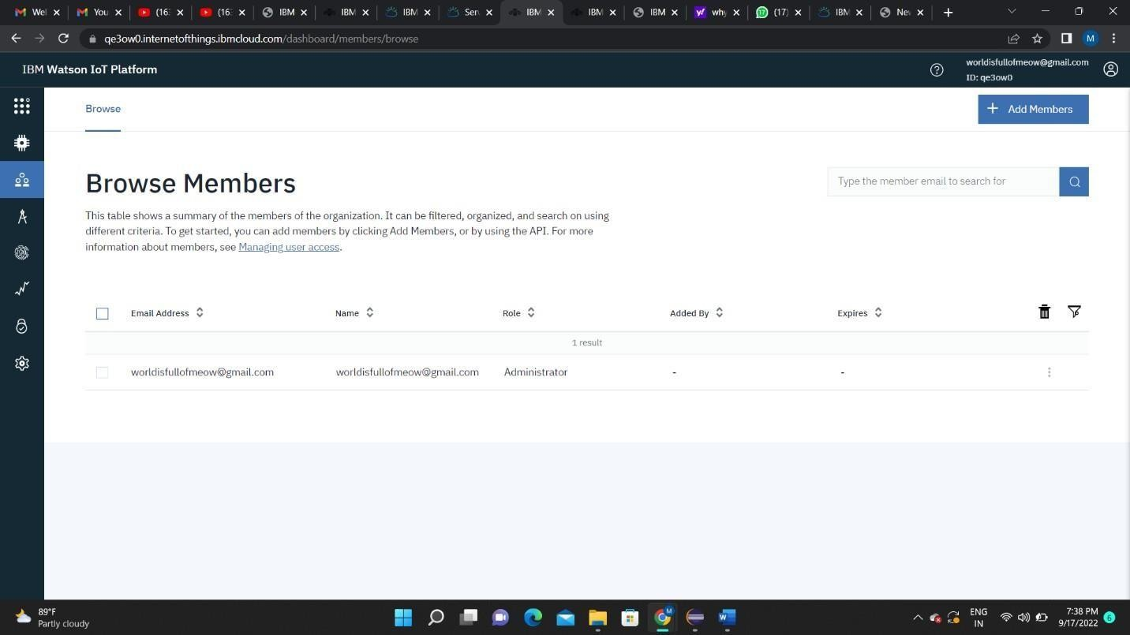

1. This tab is used when you want to connect to some other platform and to integrate with other services.

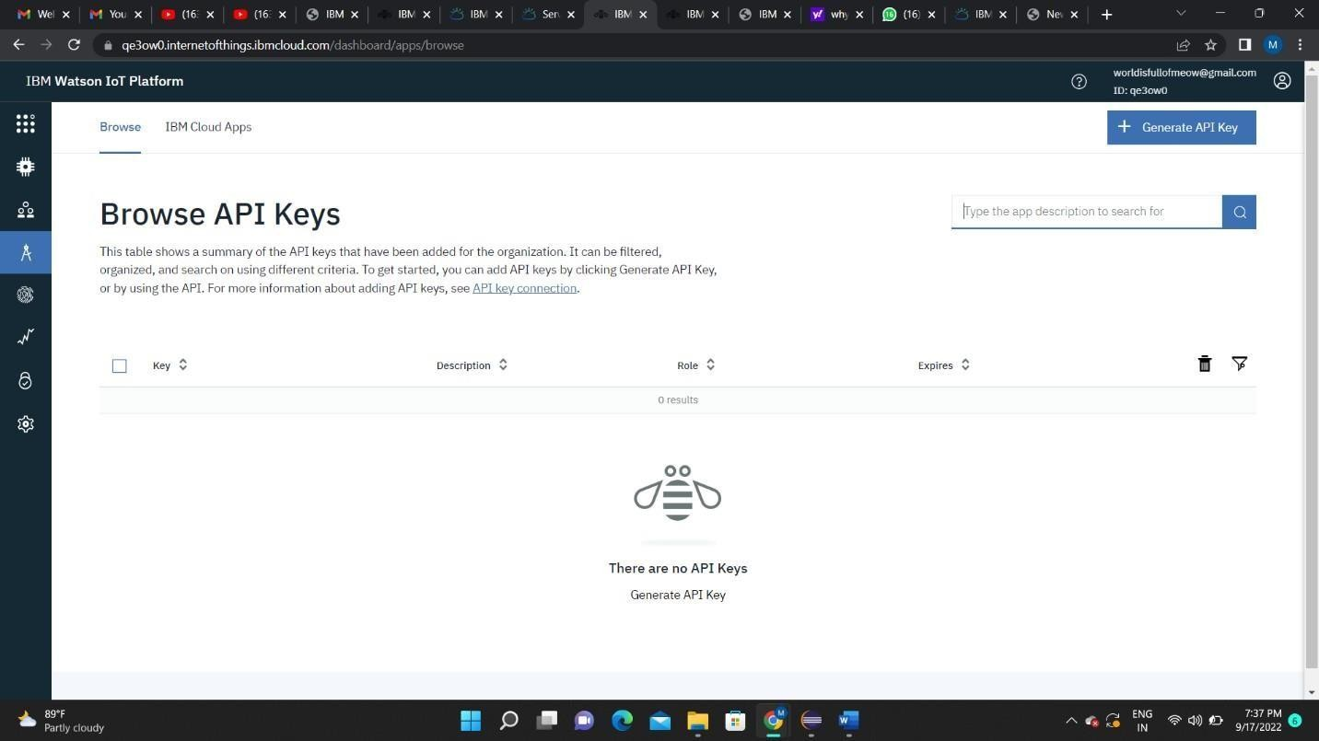

1. Click on the device tab and click on the add device button, then give the device type and device id and click next

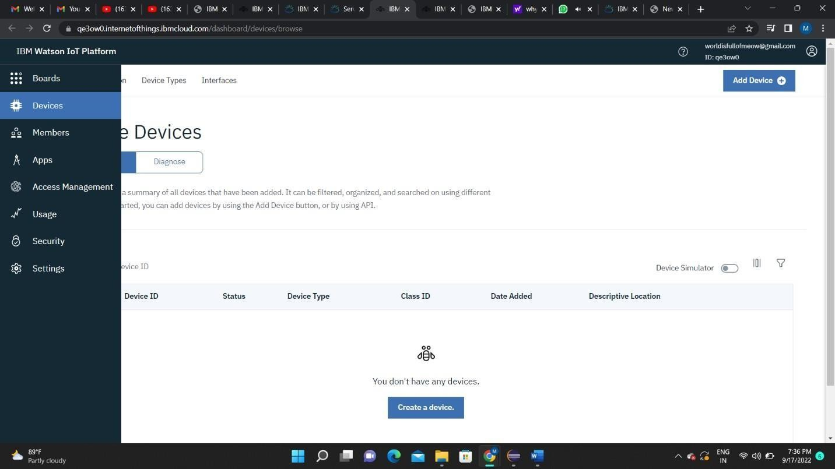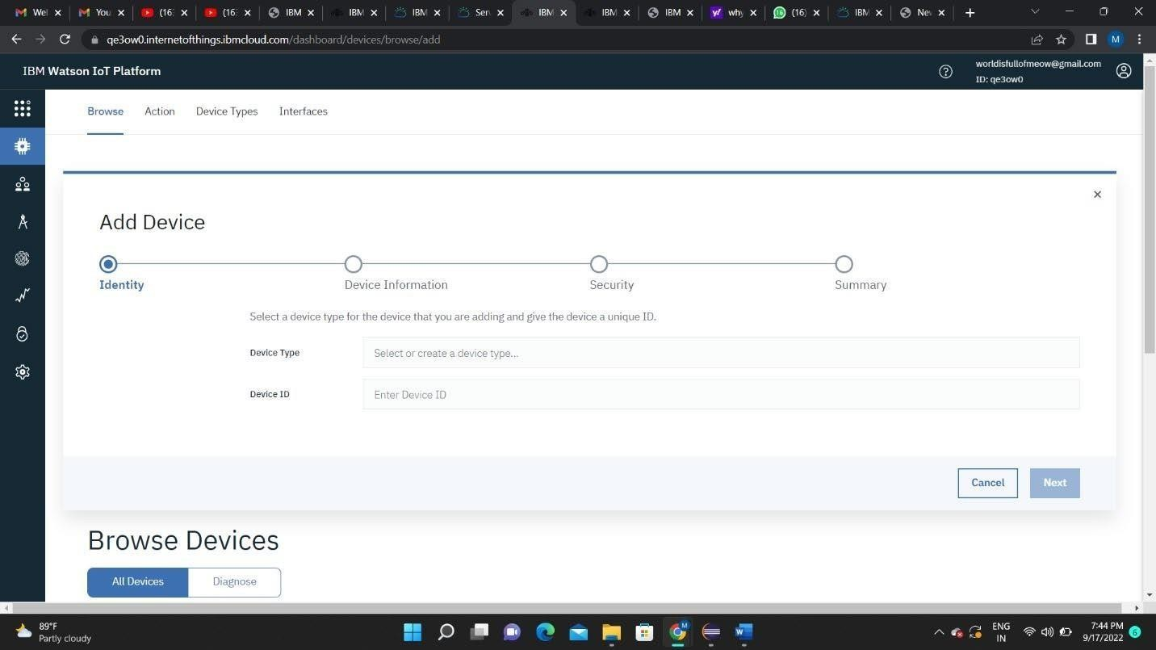

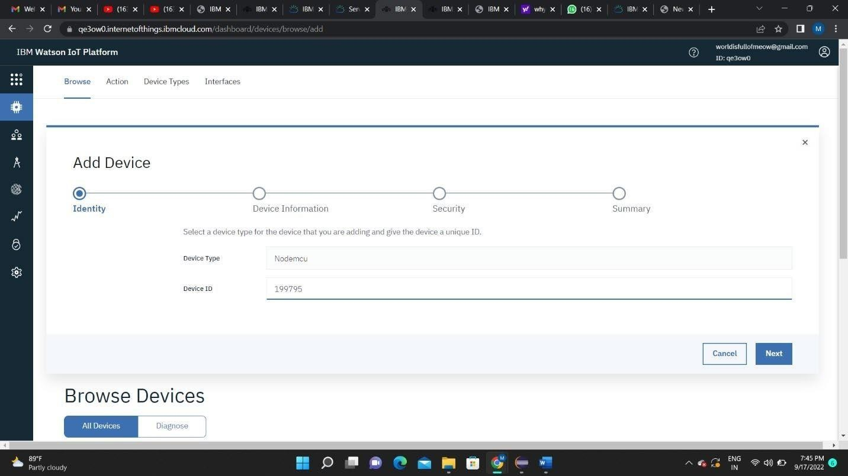

1. This page to enter extra details and of the hardware

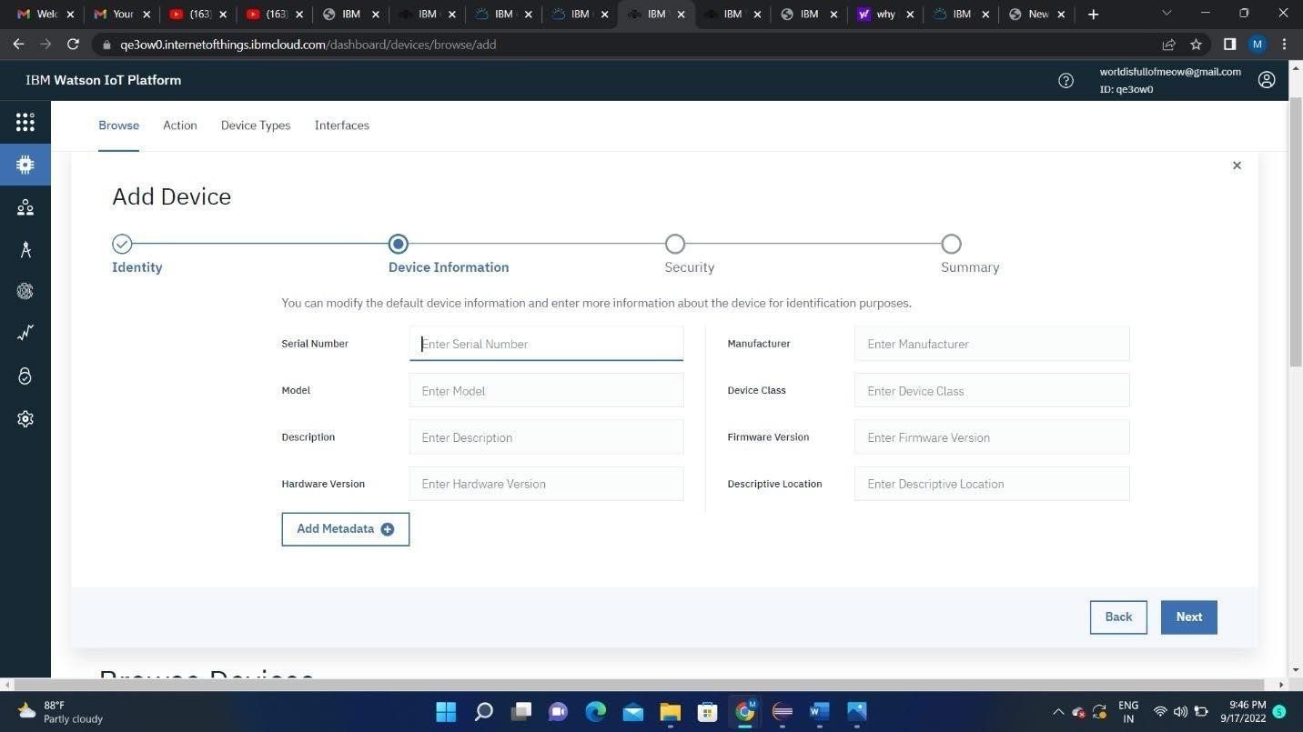

1. Clicking next it goes to the security where we do authentication token id.

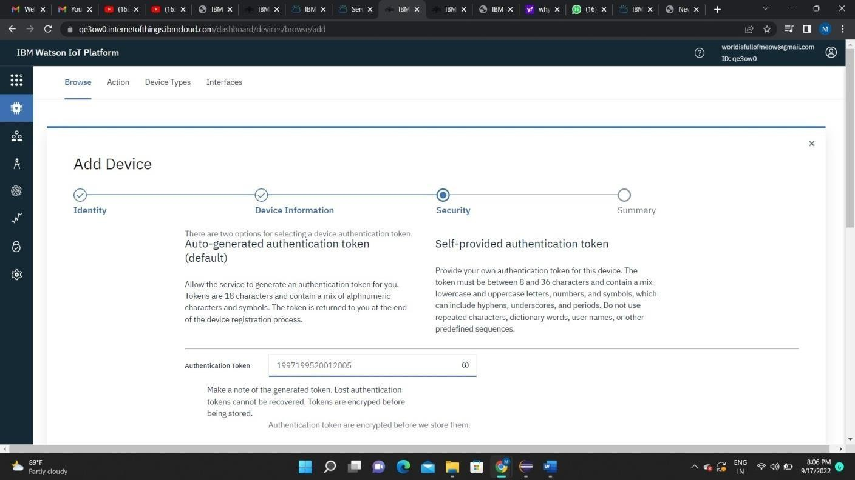

1. Clicking on next it goes to the summary of the device then click finish

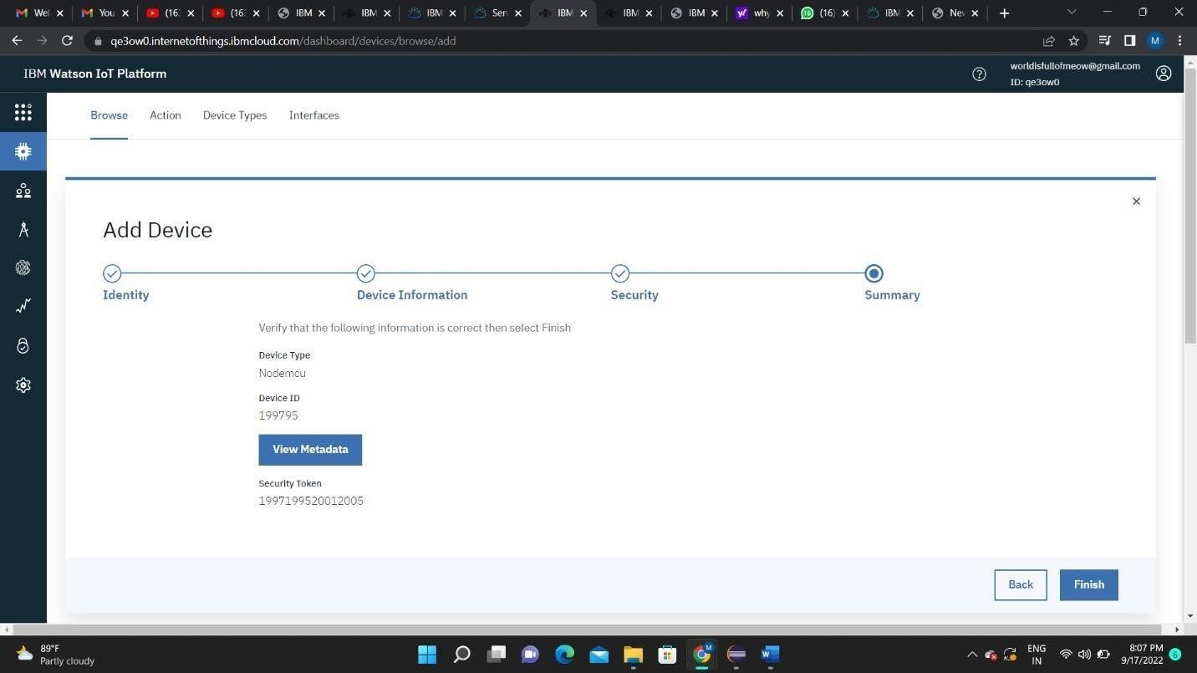

1. The device credentials will be displayed with all the details

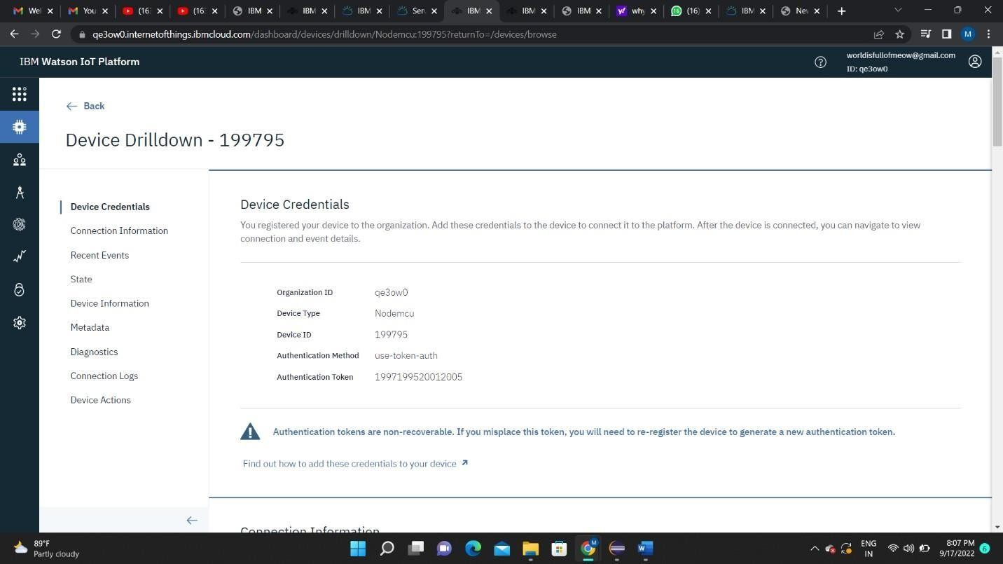

1. Safe the details of the device as the authentication tokens are non- recoverable and if misplaced then we have to create a new one.

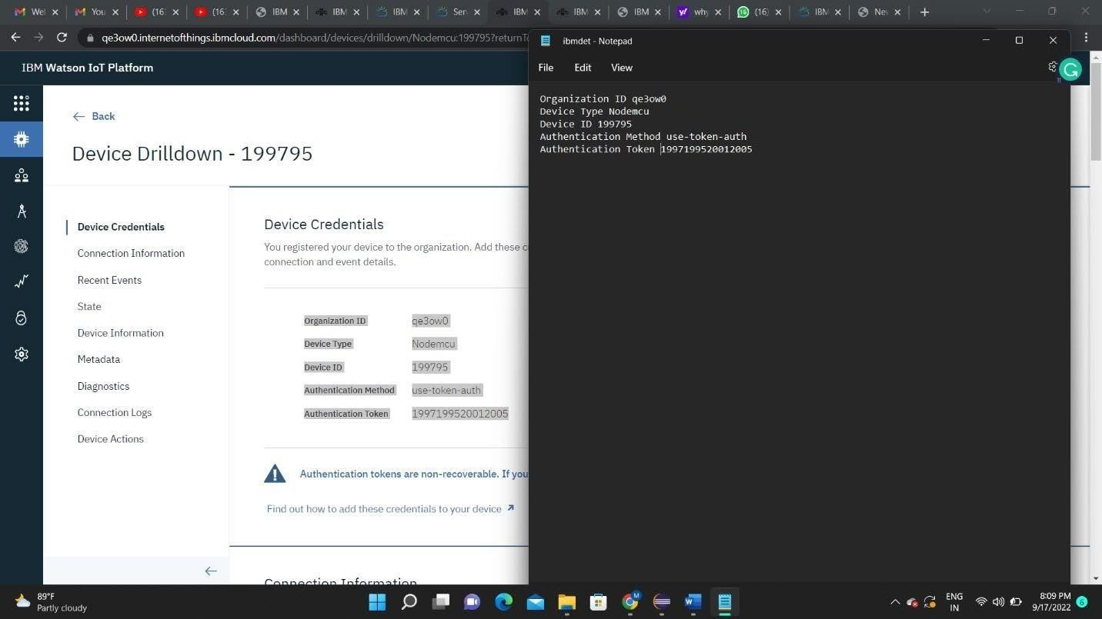

1. Clicking on the device tab we can now see the added device. Clicking on it will display the other details.

It has different tabs like Identity, Device Information, State and login.

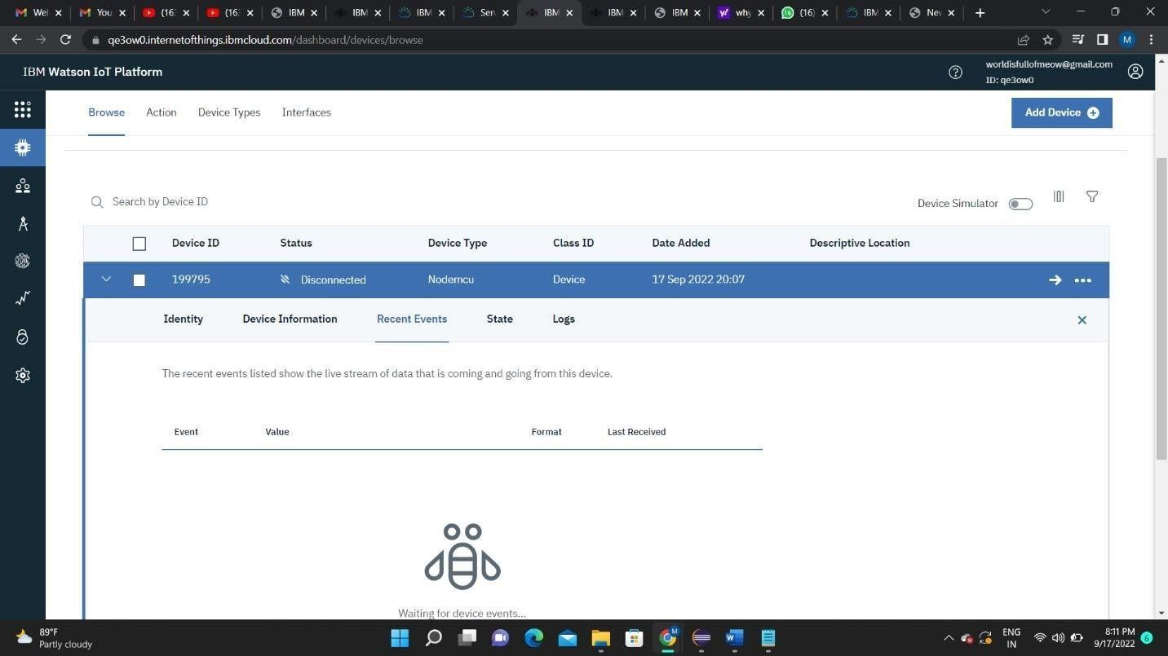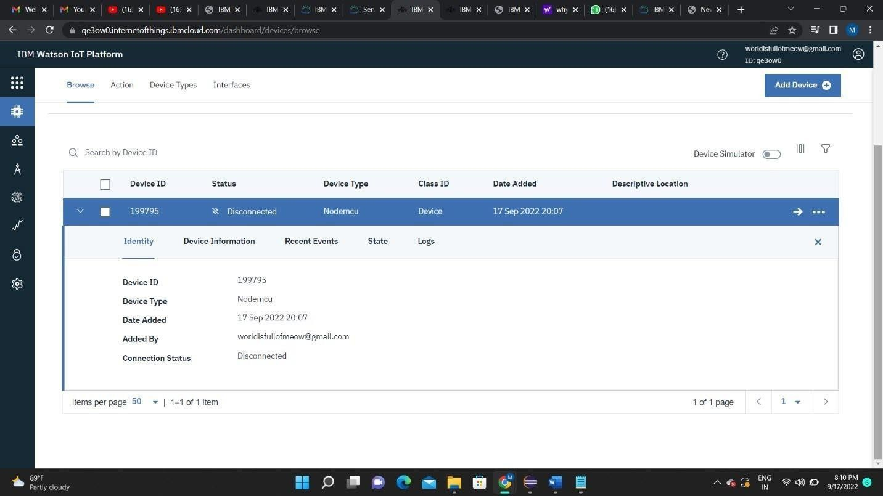

In a similar way, we can create n number of devices with a 50 per page limit as per the requirement of our project.

1. The Boards will display card for the project.

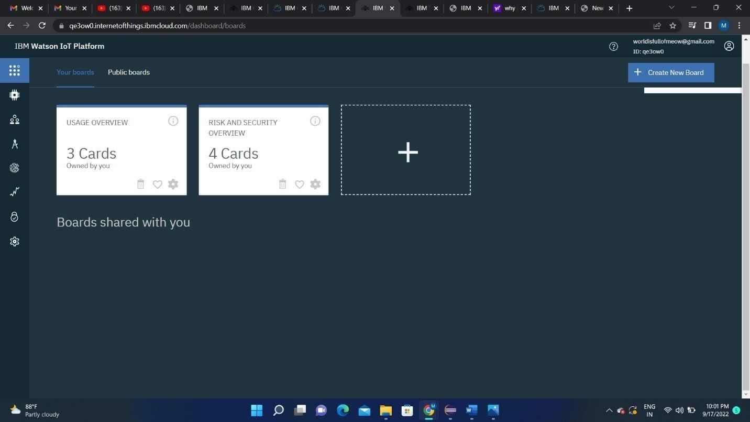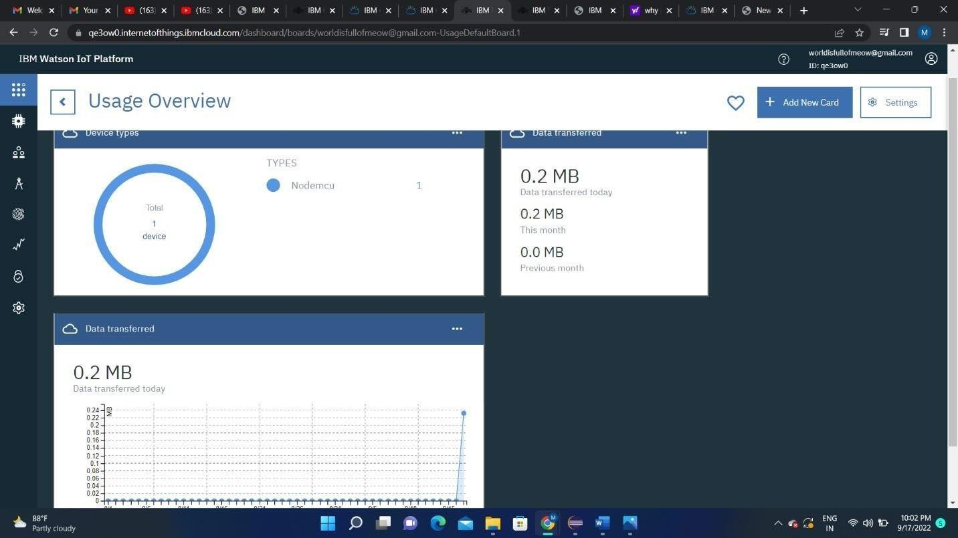

# RESULT:

An IBM Watson cloud for IoT and a device is created